

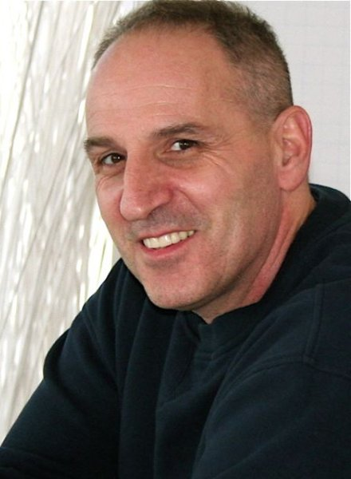

Eric Kohner CPCC, MCC

CTI FACULTY MEMBER

Fluent in English

Eric is most well known as a master in developing leaders using techniques that are both deeply transformative and, at the same time, incredibly fun. A senior trainer with CTI, Eric is a pioneer of the coaching profession. He is known for his fearlessness in calling people forth for the sake of their learning and leadership. Eric is a catalyst for leadership excellence across cultures, and has delivered training programs on five continents. Prior to becoming a coach and leadership trainer, Eric worked for 20 years in the entertainment industry appearing on stage as well as in film and television. Eric has broken new ground in leadership development by applying his acting expertise to his work

# EDUCATION

De Sales College, Bachelor of Arts in Theater and Speech.

# PROFESSIONAL BACKGROUND

# eKCosystem - Founder, Executive Coach, Leadership Development Trainer, 2009 – Present.

# CTI - Senior Leader for Coach Training Programs, Supervisor and Certification Examiner for coach training program, 1994 - Present.

CTI - Sales Manager for New York City Region, 2011 - Present.

CTI - Train the Trainers for new CTI leaders, 2002 – 2007.

Limit Busters – Founder, Executive Coach, Leadership Development Trainer.

Professional Actor, Director and Producer for theater, television and film, 1980 – Present.

# CERTIFICATIONS

Master Certified Coach, MCC, International Coach Federation.

Certified Professional Co-Active Coach, CPCC, The Coaches Training Institute.

Co-Active Leadership Program, The Coaches Training Institute.

True Colors Typing Program.

# SELECTED WORKSHOPS

Designed and delivered leadership program for VPs and Top 200: 2.5 day workshop.

Designed and delivered leadership program for Future Board Members: 1.5 day workshop.

Designed and delivered leadership skills for public: 2.5 day workshop.

Designed and delivered coaching skills program for consultants, managers and executives: 3 day workshop, tele-classes.

Delivered coaching skills program for public: series of 3 day workshops.

_____________________________________________________________________________________

**Tel: +34 938 112 227, +1 626 351 5514, ekohner@aol.com**